Time of the End
when does it begin?

Two different things:
- End of time
- Time of the end

End of time prophecy
Revelation 10:6. “And sware by him that liveth for ever and ever, who created heaven, and the things that therein are, and the earth, and the things that therein are, and the sea, and the things which are therein, that there should be time no longer:”

“I plainly stated at the Jackson camp meeting to these fanatical parties that they were doing the work of the adversary of souls; they were in darkness. They claimed to have great light that probation would close in October, 1884. I there stated in public that the Lord had been pleased to show me that there would be no definite time in the message given of God since 1844.” —Selected Messages 2:73 (1885). LDE 35.3

“Our position has been one of waiting and watching, with no time-proclamation to intervene between the close of the prophetic periods in 1844 and the time of our Lord's coming.” —Manuscript Releases 10:270 (1888). LDE 36.1

“The people will not have another message upon definite time. After this period of time [Revelation 10:4-6], reaching from 1842 to 1844, there can be no definite tracing of the prophetic time. The longest reckoning reaches to the autumn of 1844.” —The S.D.A. Bible Commentary 7:971 (1900). LDE 36.2

“Pym [in his Word of Warning (1841)] affords an interesting example of progressive change in prophetic interpretation. According to the Preface of his Word of Warning, he reached a time, several years prior, ‘when it pleased God to incline mine heart to receive these doctrines.’ Then, in 1829, he felt constrained to send forth his Thoughts on Millenarianism, to help ‘warn the world’ of the “speedy appearing” of Christ. But at that time his emphasis was upon the 1335-year time prophecy, which he then thought would terminate in 1867. But by 1835 his mind had been directed to the 2300 years, as beginning synchronously with the seventy weeks and terminating in 1847, by which time he expected the advent. Pym was one of the British works publicized in the earliest issues of the American Millerite Signs of the Times, in 1840. 105 –Leroy Froom, Prophetic Faith of our Fathers 3 570.3 [William Wollaston Pym (1792-1852)]

If 1844 was the end of time prophecy then, then the 1335 must also end then. Therefore the 1290 must also end in 1798 and therefore begin in 508. What happened in 508?

Time of the end
Daniel 8:15-17. “And it came to pass, when I, even I Daniel, had seen the vision, and sought for the meaning, then, behold, there stood before me as the appearance of a man. ¹⁶ And I heard a man's voice between the banks of Ulai, which called, and said, Gabriel, make this man to understand the vision. ¹⁷ So he came near where I stood: and when he came, I was afraid, and fell upon my face: but he said unto me, Understand, O son of man: for at the time of the end shall be the vision.”

Daniel 12:4, 9. “But thou, O Daniel, shut up the words, and seal the book, even to the time of the end: many shall run to and fro, and knowledge shall be increased…. ⁹ And he said, Go thy way, Daniel: for the words are closed up and sealed till the time of the end.”

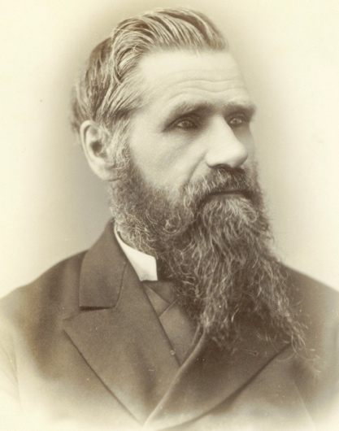
Elder Stephen Haskell (1833 – 1922) writes concerning the time of the end:
Elder Stephen Haskell (1833 – 1922)
"The words are closed up and sealed till the time of the end." But the time of the end has come. It began in 1798, and though "none of the wicked shall understand," yet "the wise shall understand." With the book of Daniel in hand, and a heart open to hear the voice of God, man may come in touch with the Father of light. "He that hath an ear, let him hear what the Spirit saith." {1901 SNH, SDP 13.2}
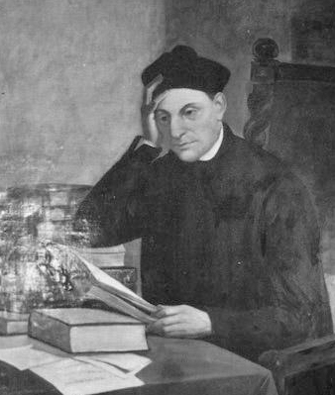
Haskell points out that 1798 was the beginning of the first industrial revolution: the cotton gin, the Steam engine, the electric motor… scientific and industrial Knowledge has been increasing since then at an ever-increasing rate. But the knowledge and understanding of the Book of Daniel has also been going forward exponentially….
Manual Lacunza (1731–1801)
“It is clearly stated that at the time of the end the Book of Daniel would be opened. How was this so? Years before 1844 men like Manual Lacunza (1731–1801) was writing and speaking about the prophecies of the second coming and pointing to the book of Daniel. Lacunza’s lawyer in the inquisition, Dr. Jose Maria Gutierrez de Rozas (1769-1848), in studying for his defense, he became familiar with dissentient literature, which evidently interested him in Scripture study. In 1834, “De Rozas wrote a book in which he contended that Lacunza was a good Catholic, and that he was simply misunderstood, and that his treatise should not have been put on the Roman Index Prohibitorum.”
So the teaching of a coming judgment based on the opening of the prophecies in the book of Daniel was being presented by men like Manuel Lacunza, Joseph Wolf who Between 1821 and 1826 he traveled as a missionary in Egypt and the Levant, and was the first modern missionary to preach to the Jews near Jerusalem, William Miller who began public ministry and preaching from 1931, and others who went to the book of Daniel well before 1844.

Uriah Smith in his Daniel and Revelation puts it this way.
“An increase of knowledge respecting the prophetic portions of the word of God was to be one of the characteristics of the last days. Said the angel to Daniel, "But thou, O Daniel, shut up the words, and seal the book, even to the time of the end: many shall run to and fro, and knowledge shall be increased;" or, as Michaelis's translation reads: "When many shall give their sedulous attention to the understanding of these things, and knowledge shall be increased." –Uriah Smith, Daniel and Revelation 5.

Smith states much later
“Further evidence regarding the time is supplied by the prophecy of Dan. 12:11, where it is stated that "from the time that the daily sacrifice shall be taken away, ... there shall be a thousand two hundred and ninety days." As verses 4, 6, 7, 8, 9 of this chapter speak of the "time of the end," we may reasonably conclude the same time is meant in verse 11. Reckoning back 1290 "days," or years, from the "time of the end," which began A.D. 1798 (see p. 290), we are brought to the year A.D.508.
“From these evidences we think it clear that the daily, or paganism, was taken away in A.D.508. This was preparatory to the setting up, or establishment of the papacy, which was a separate and subsequent event. Of this the prophetic narrative now leads us to speak.… –1897 Uriah Smith, Daniel and Revelation 285.
[On page 290, after first quoting Daniel 11:35, “And some of them of understanding shall fall, to try them, and to purge, and to make them white, even to the time of the end: because it is yet for a time appointed.” Uriah Smith comments:]
“Though restrained, the spirit of persecution was not destroyed. It broke out whenever there was opportunity. Especially was this the case in England. The religious state of that kingdom was fluctuating, it being sometimes under Protestant, and sometimes papal jurisdiction, according to the religion of the ruling house. The bloody Queen Mary was a mortal enemy to the Protestant cause, and multitudes fell victims to her relentless persecutions. And this condition of affairs was to last more or less to the time of the end. The natural conclusion would be that when the time of the end should come, this power which the Church of Rome had possessed to punish heretics, which had been the cause of so much persecution, and which for a time had been restrained, would now be taken entirely away; and the conclusion would be equally evident that this taking away of the papal supremacy would mark the commencement of the period here called the "time of the end." If this application is correct, the time of the end commenced in 1798; for there, as already noticed, the papacy was overthrown by the French, and has never since been able to wield the power it before possessed. That the oppression of the church by the papacy is what is here referred to, is evident, because that is the only one, with the possible exception of Rev.2:10, connected with a "time appointed," or a prophetic period. {1897 Uriah Smith, Daniel and Revelation 290.3}

St. Bartholomew's Day massacre August 24/25, 1572. Modern estimates for the number of dead across France vary widely, from 5,000 to 30,000. I have read 70,000 throughout France. [https://en.wikipedia.org/wiki/St._Bartholomew%27s_Day_massacre]

1378 – morning star of the Reformation
1588 – Spanish Armada destroyed
1798 – Deadly wound – and the woman comes out of the wilderness
2008 – Deadly wound fully healed

The Edict of Nantes was signed 26 years later in April 1598 by King Henry IV and granted the Calvinist Protestants of France, also known as Huguenots, substantial rights in the nation, which was predominantly Catholic. In the edict, Henry aimed primarily to promote civil unity.

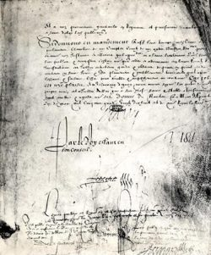
Edict of Nantes
- A first warrant guaranteed the Protestants an annual grant of 4500 crowns; this enabled them to hold their services and specially to pay their “ministers” (pastors).
- The actual edict itself consisting of 92 articles, was “permanent and irrevocable” – meaning that it could not be revoked by a new edict.
- A second warrant guaranteed the Protestants 150 places of refuge for a period of 8 years – 51 of these were strongholds, which the Protestants were to garrison for their security. (This warrant was renewed in 1606 and 1611 but suppressed by the “Peace of Alès” in 1629).
- 56 articles, said to be “secret and specific,” but of lesser importance and dealing with local situations. https://museeprotestant.org/en/notice/the-edict-of-nantes-1598/

However, 87 years later, in 1685, King Louis XIV, convinced that most Protestants had by then become Catholics, signed the revocation of the edict of Nantes in Fontainebleau France.

“In the Revelation all the books of the Bible meet and end. Here is the complement of the book of Daniel. One is a prophecy; the other a revelation. The book that was sealed is not the Revelation, but that portion of the prophecy of Daniel relating to the last days. The angel commanded, ‘But thou, O Daniel, shut up the words, and seal the book, even to the time of the end.’” Daniel 12:4. –The Acts of the Apostles 585.1
It is true that in the time of the end, when God's work in the earth is closing, the earnest efforts put forth by consecrated believers under the guidance of the Holy Spirit, are to be accompanied by special tokens of divine favor. Under the figure of the early and the latter rain, that falls in Eastern lands at seed-time and harvest, the Hebrew prophets foretold the bestowal of spiritual grace in extraordinary measure upon God's church. The out-pouring of the Spirit in the days of the apostles was the beginning of the early, or former rain, and glorious was the result. To the end of time, the presence of the Spirit is to abide with the true church.” —The Acts of the Apostles, 54, 55.
The outpouring of the Spirit in the days of the apostles was the “former rain,” and glorious was the result. But the latter rain will be more abundant. What is the promise to those living in these days? —“Turn you to the stronghold, ye prisoners of hope; even today do I declare that I will render double unto thee.” “Ask ye of the Lord rain in the time of the latter rain; so the Lord shall make bright clouds, and give them showers of rain, to every one grass in the field.” —Testimonies for the Church 8:21.

As the message of Christ's first advent announced the kingdom of His grace, so the message of His second advent announces the kingdom of His glory. And the second message, like the first, is based on the prophecies. The words of the angel to Daniel relating to the last days were to be understood in the time of the end. At that time, “many shall run to and fro, and knowledge shall be increased.” “The wicked shall do wickedly: and none of the wicked shall understand; but the wise shall understand.” Daniel 12:4, 10. The Saviour Himself has given signs of His coming, and He says, “When ye see these things come to pass, know ye that the kingdom of God is nigh at hand.” “And take heed to yourselves, lest at any time your hearts be overcharged with surfeiting, and drunkenness, and cares of this life, and so that day come upon you unawares.” “Watch ye therefore, and pray always, that ye may be accounted worthy to escape all these things that shall come to pass, and to stand before the Son of man.” Luke 21:31, 34, 36. DA 234.4
We have reached the period foretold in these scriptures. The time of the end is come, the visions of the prophets are unsealed, and their solemn warnings point us to our Lord's coming in glory as near at hand. DA 235.1

The message itself sheds light as to the time when this movement is to take place. It is declared to be a part of the “everlasting gospel;” and it announces the opening of the Judgment. The message of salvation has been preached in all ages; but this message is a part of the gospel which could be proclaimed only in the last days, for only then would it be true that the hour of Judgment had come. The prophecies present a succession of events leading down to the opening of the Judgment. This is especially true of the book of Daniel. But that part of his prophecy which related to the last days, Daniel was bidden to close up and seal “to the time of the end.” Not till we reach this time could a message concerning the Judgment be proclaimed, based on a fulfillment of these prophecies. But at the time of the end, says the prophet, “many shall run to and fro, and knowledge shall be increased.” [Daniel 12:4.] GC88 355.3

–Leroy Froom, Prophetic Faith of our Fathers 4.303.1
De Rozas supported Lacunza’s proposition of following a literal interpretation of Scripture in every case where it is not obviously a symbol (pp. 18-20) and held that a literal interpretation is needed as the foundation for any allegorical exposition or spiritual interpretation (pp. 22, 23). He declared Lacunza did not violate the accepted teachings of the Fathers, since the Fathers were not all in agreement (p_. 38). He upheld Lacunza’s charge that there is an almost total forgetting of study of Scripture among the priests (pp. 47-49), and approved the former’s comparison of the Jewish priests’ mistaking Christ’s first advent, as Catholic priests were now mistaking His second advent (pp. 59-63). Lacunza also believed Antichrist to be, not an individual, but a moral body of men, quoting with approval printed at least twice in Mexico.” –Footnote to Leroy Froom, Prophetic Faith of our Fathers 4.303.1

